### BLOCKCHAIN BASED CERTIFICATE VERIFICATION SYSTEM”

### A PROJECT REPORT

*Submitted by*

**Y.Uma Venkat Reddy [Reg No:RA211271010019]**

*Under the Guidance of*

### Dr. PAUL T SHEEBA

#### (Assistant Professor, Department of Data Science and Business Systems)

*In partial fulfillment of the Requirements for the Degree of*

## BACHELOR OF TECHNOLOGY COMPUTER SCIENCE AND BUSINESS SYSTEMS



**DEPARTMENT OF DATA SCIENCE AND BUSINESS SYSTEMS**

## FACULTY OF ENGINEERING AND TECHNOLOGY SRM INSTITUTE OF SCIENCE AND TECHNOLOGY NOVEMBER 2022

Department of Data Science and Business Systems

###### SRM Institute of Science & Technology Own Work\* Declaration Form

To be completed by the student for all assessments

###### Degree/ Course :

**Student Name :**

###### Registration Number :

**Title of Work :**

We hereby certify that this assessment complies with the University’s Rules and Regulations relating to Academic misconduct and plagiarism\*\*, as listed in the University Website, Regulations, and the Education Committee guidelines.

We confirm that all the work contained in this assessment is our own except where indicated, and that we have met the following conditions:

* Clearly references / listed all sources as appropriate
* Referenced and put in inverted commas all quoted text (from books, web, etc)
* Given the sources of all pictures, data etc. that are not my own
* Not made any use of the report(s) or essay(s) of any other student(s) either past or present
* Acknowledged in appropriate places any help that I have received from others (e.g. fellow students, technicians, statisticians, external sources)
* Compiled with any other plagiarism criteria specified in the Course handbook / University website

We understand that any false claim for this work will be penalized in accordance with the University policies and regulations.

|  |
| --- |
| **DECLARATION:** |
| I am aware of and understand the University’s policy on Academic misconduct and plagiarism and I certify that this assessment is my / our own work, except where indicated by referring, and that I have followed the good academic practices noted above. |
| If you are working in a group, please write your registration numbers and sign with the date for every student in your group. |

SRM INSTITUTE OF SCIENCE AND TECHNOLOGY KATTANKULATHUR-603203

BONAFIDE CERTIFICATE

Certified that this project report titled “**Library Management System”** is the bonafide work of **“HIRIDHARAN N [Reg No:RA2112701010010], RUDRRESH P[Reg No:RA2112701010020] and P V THARUNN RAJ [Reg No:RA2112701010004]** who carried out the project work under my supervision. Certified further, that to the best of my knowledge the work reported herein does not form part of any other thesis or dissertation on the basis of which a degree or award was conferred on an earlier occasion for this or any other candidate.

Dr. Paul T Sheeba Dr. M. Lakshmi

##### GUIDE HEAD OF THE DEPARTMENT

Assistant Professor Dept. of DSBS Dept. of DSBS

Signature of Internal Examiner Signature of External Examiner

**ABSTRACT**

### Library Management System

### Libraries are power houses of knowledge which enable people to obtain and develop knowledge, it also helps people with studies clearing their doubts and queries without the help of others.

### Managing libraries efficiently helps reduce time required for searching for the required book, it also helps keep record of borrowed books helping to find lost books and defaulters along with these benefits it helps the library management system keeps track of time for borrowed books.

### Library management system is a simple console application using linked list in C programming language. User can perform basic library management operations like issuing books, returning the issued books and displaying records of the issued books with the user details. Each book in the library has a unique identification number. The user issues the book by entering the book ID and the user details. Each user can issue only one book at a time. When the user returns the issued book, the book is available in the library for issuing again. The record of the issued book with user details can also be viewed.

### ACKNOWLEDGEMENTS

We express our humble gratitude to **Dr C. Muthamizhchelvan**, Vice-Chancellor, SRM Institute of Science and Technology, for the facilities extended for the project work and his continued support. We extend our sincere thanks to Dean-CET, SRM Institute of Science and Technology, **Dr T.V.Gopal**, for his invaluable support.

We wish to thank **Dr Revathi Venkataraman**, Professor & Chairperson, School of Computing, SRM Institute of Science and Technology, for her support throughout the project work. We are incredibly grateful to our Head of the Department**, Dr M. Lakshmi** Professor, Department of Data Science and Business Systems, SRM Institute of Science and Technology, for her suggestions and encouragement at all the stages of the project work. We want to convey our thanks to our program coordinator **Dr.E.Sasikala,** Professor, Department of Data Science and Business Systems, SRM Institute of Science and Technology, for her input during the project reviews and support.

We register our immeasurable thanks to our Faculty Advisor**, Dr. R Rajkumar,** Assistant Professor, DSBS, SRM Institute of Science and Technology, for leading and helping us to complete our course.

Our inexpressible respect and thanks to my guide, **Dr. Paul T Sheeba,** Assistant Professor, DSBS, SRM Institute of Science and Technology, for providing me with an opportunity to pursue my project under his mentorship. He provided me with the freedom and support to explore the research topics of my interest. His passion for solving problems and making a difference in the world has always been inspiring. We sincerely thank the Data Science and Business Systems staff and students, SRM Institute of Science and Technology, for their help during our project. Finally, we would like to thank parents, family members, and friends for their unconditional love, constant support, and encouragement.

N HIRIDHARAN

RUDRRESH P

P V THARUNN RAJ

## TABLE OF CONTENTS

|  |  |  |  |  |
| --- | --- | --- | --- | --- |
| TABLE OF CONTENTS | | | | |
| CHAPTER NO. | | | TITLE | PAGE NO. |
|  | ABSTRACT | |  | iii |
|  | LIST OF TABLES | |  | vii |
|  | LIST OF FIGURES | |  | viii |
|  | LIST OF ABBREVIATIONS | |  | ix |
| 4 | SYSTEM DESIGN | |  |  |
|  |  |  | |  |
|  |  |  |  |  |
|  |  |  |  |  |
|  |  |  |  |  |
|  |  |  |  |  |
|  | 4.3 | ARCHITECTURE |  |  |

|  |  |  |
| --- | --- | --- |
| 5 | OUTPUT | 47 |
| 6 | CONCLUSION 48 | |
| 7 | FUTURE ENHANCEMENTS 49 | |
| 8 | REFERENCES 50 | |
|  |
|  |
|  |  |  |

|  |  |
| --- | --- |
|  | **LIST OF FIGURES** |
| 1.1 |  |
| 1.2 |  |
| 1.3 |  |
|  |  |

## ABBREVIATIONS

|  |  |
| --- | --- |
| **GUI** | Graphical User Interface |
| **C** | C language |
| **PTP** | Peer To Peer |
| **STRUCT** | Data Structures |
| **LL** | Linked List |
| **STK** | Stack |
| **STR** | String |
|  |  |

**CHAPTER 1**

## SYSTEM DESIGN

## 1.1 ACTIVITY DIAGRAM

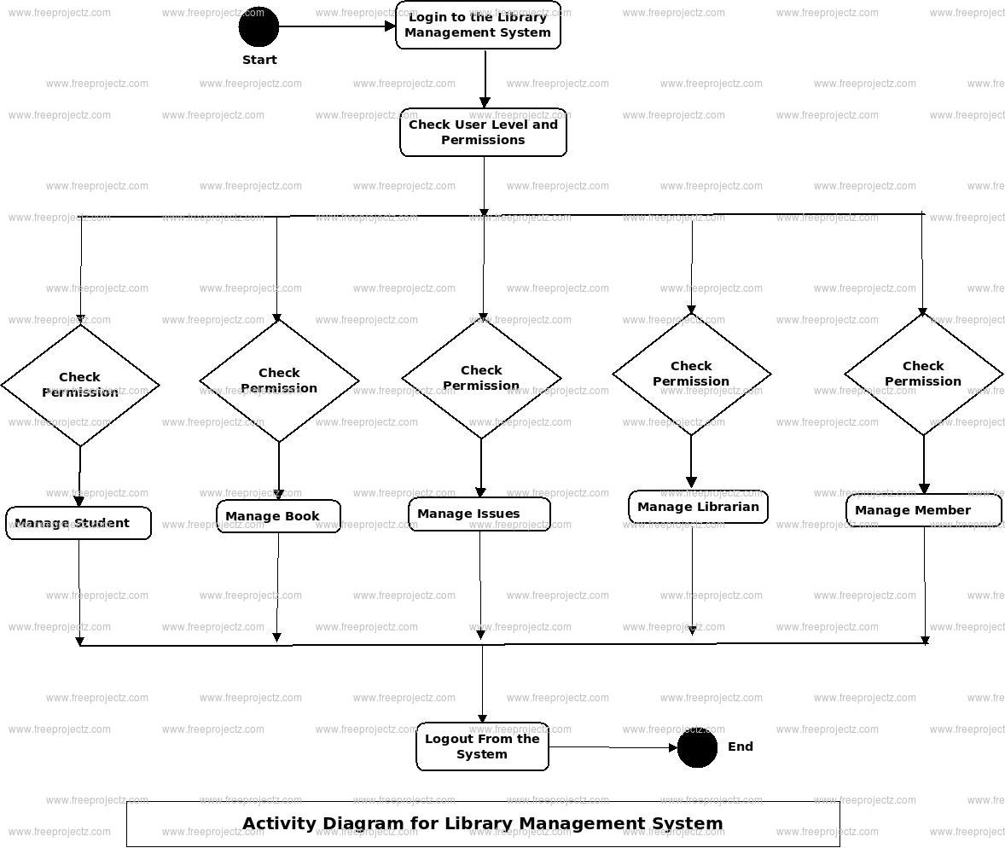

**1.2 ARCHITECTURE DIAGRAM**

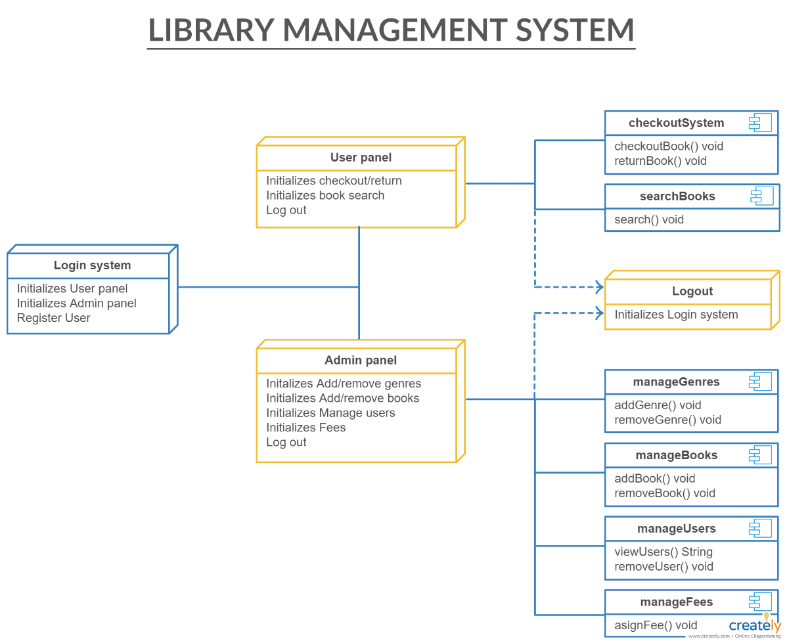

**CHAPTER 2**

**OUTPUT**

# 1.3 First page output:

# C:\Users\HIRIDHARAN\Videos\Captures\E__Library-Management-System-using-Data-Structures-main_Library_Management_System.exe 20-11-2022 09_59_47 PM.png

**FIG 1.1**

**Student details output:**

**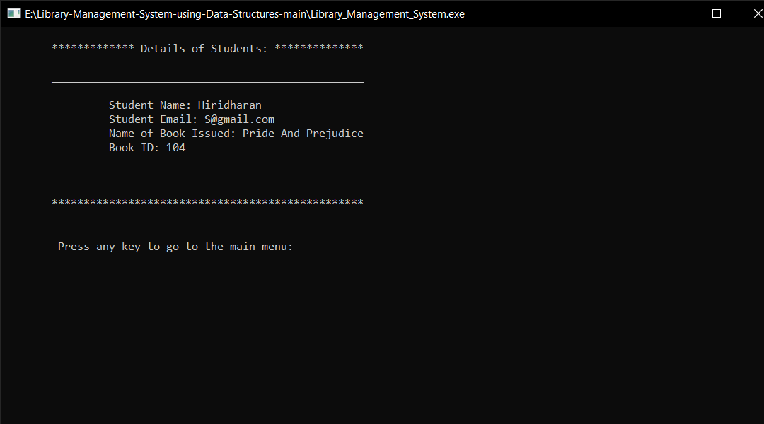**

**FIG 1.2**

**Book Returnee output:**

**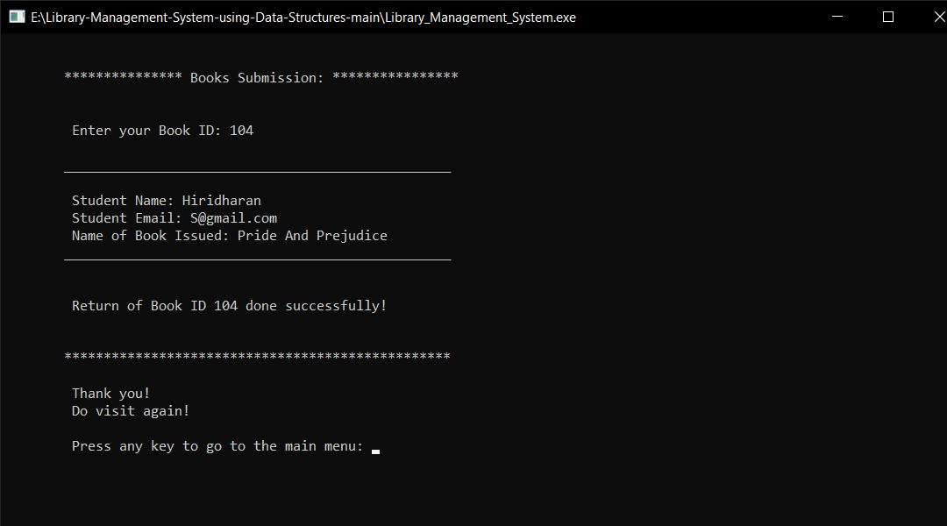**

**FIG 1.3**

**CHAPTER 3**

**CONCLUSION**

Library Management system is sure to provide a soulution to improve uniformity and integrity among students, book enthusiasts, readers and librarian by improving the system organizationally and basically by alleviating user experience and providing a better way to organize and find

## CHAPTER 4 REFERENCES

1. Book of Data structures through C G. S Baluja.

2. Pieren Garry Department of computer science

New York University.

3.Paul Xavier department of algorithms in c

Amsterdam.

4. Surendrakumar Ahuja IItdelhi department of

computer science delhi .

5. Nick jones department of data mining Australia.

6.Wikipedia sequential search.

|  |
| --- |
|  |
|  |
|  |  |

## APPENDIX

**SourceCode:**

**#include <stdio.h>**

**#include <conio.h>**

**#include <stdlib.h>**

**#include <malloc.h>**

**#include <string.h>**

**struct book{**

**char name[30];**

**char author[30];**

**int id;**

**struct book \*next;**

**};**

**struct student{**

**char name[30];**

**char email[20];**

**char book[20];**

**char a[30];**

**int id;**

**struct student \*next;**

**};**

**struct book \*start\_lib=NULL;**

**struct student \*start=NULL;**

**struct book \*initialize\_lib(struct book \*);**

**struct student \*book\_issue(struct student \*);**

**struct student \*book\_return(struct student \*);**

**struct book \*diplay\_lib(struct book \*);**

**struct book \*delete\_book(int);**

**struct book \*add\_book(char [],char [],int);**

**void display(struct student \*);**

**void greetings();**

**void main\_menu();**

**int main(){**

**start\_lib=initialize\_lib(start\_lib);**

**greetings();**

**main\_menu();**

**return 0;**

**}**

**void greetings(){**

**printf("\n\n");**

**printf("\t\t\t \*\*\*\*\*\*\*\*\*\*\*\*\*\*\*\*\*\*\*\*\*\*\*\*\*\*\*\*\*\*\*\*\*\*\*\*\*\*\*\*\n");**

**printf("\t\t\t \* \*\n");**

**printf("\t\t\t \* \*\n");**

**printf("\t\t\t \* ---------------------------- \*\n");**

**printf("\t\t\t \* WELCOME TO STUDENT LIBRARY \*\n");**

**printf("\t\t\t \* ---------------------------- \*\n");**

**printf("\t\t\t \* \*\n");**

**printf("\t\t\t \* \*\n");**

**printf("\t\t\t \*\*\*\*\*\*\*\*\*\*\*\*\*\*\*\*\*\*\*\*\*\*\*\*\*\*\*\*\*\*\*\*\*\*\*\*\*\*\*\*\n");**

**printf("\n\n");**

**printf("\t\t\t \*\*\*\*\*\*\*\*\*\*\*\*\*\*\*\*\*\*\*\*\*\*\*\*\*\*\*\*\*\*\*\*\*\*\*\*\*\*\*\*\n");**

**printf("\t\t\t \* \*\n");**

**printf("\t\t\t \* ------------------------ \*\n");**

**printf("\t\t\t \* STUDENT LIBRARY \*\n");**

**printf("\t\t\t \* ------------------------ \*\n");**

**printf("\t\t\t \* \*\n");**

**printf("\t\t\t \* \*\n");**

**printf("\t\t\t \* Mumbai,Maharashtra,India \*\n");**

**printf("\t\t\t \* Email: studentlib@gmail.com \*\n");**

**printf("\t\t\t \* Contact:8800991010,8800992020 \*\n");**

**printf("\t\t\t \* \*\n");**

**printf("\t\t\t \*\*\*\*\*\*\*\*\*\*\*\*\*\*\*\*\*\*\*\*\*\*\*\*\*\*\*\*\*\*\*\*\*\*\*\*\*\*\*\*\n");**

**printf("\n\n\t\t\t Press any key to continue: ");**

**getch();**

**}**

**void main\_menu(){**

**int choice;**

**do{**

**printf("\n\n");**

**printf("\n\t\t\t\*\*\*\*\*\*\*\*\*\*\*\*\*\*\*\*\*\*\*\*\*\*\*\*\*\*\*\*\*\*\*\*\*\*\*\*\*\*\*\*\*\*\*\*\*\*\*\*\*\n");**

**printf("\n\t\t\t\t MAIN MENU: ");**

**printf("\n\t\t\t\t 1.ISSUE OF BOOKS ");**

**printf("\n\t\t\t\t 2.RETURN OF BOOKS ");**

**printf("\n\t\t\t\t 3.DISPLAY STUDENT DETAILS ");**

**printf("\n\t\t\t\t 4.EXIT\n ");**

**printf("\n\t\t\t\*\*\*\*\*\*\*\*\*\*\*\*\*\*\*\*\*\*\*\*\*\*\*\*\*\*\*\*\*\*\*\*\*\*\*\*\*\*\*\*\*\*\*\*\*\*\*\*\*\n");**

**printf("\n\t\t\t\t Enter your choice: ");**

**scanf("%d",&choice);**

**switch(choice){**

**case 1:{**

**start=book\_issue(start);**

**break;**

**}**

**case 2:{**

**start=book\_return(start);**

**break;**

**}**

**case 3:{**

**display(start);**

**break;**

**}**

**case 4:{**

**exit(1);**

**}**

**default:{**

**printf("\n\t\t\t\t ...Invalid Option!...\n");**

**printf("\n\t\t\t\t Press any key to try again: ");**

**getch();**

**}**

**}**

**}while(choice!=4);**

**}**

**struct book \*initialize\_lib(struct book \*start){**

**struct book \*ptr,\*new\_book1,\*new\_book2,\*new\_book3,\*new\_book4,\*new\_book5;**

**new\_book1=(struct book \*)malloc(sizeof(struct book));**

**new\_book1->next=NULL;**

**start\_lib=new\_book1;**

**strcpy(new\_book1->name,"The Kite Runner");**

**strcpy(new\_book1->author,"Khaled Hosseini");**

**new\_book1->id=101;**

**ptr=new\_book1;**

**new\_book2=(struct book\*)malloc(sizeof(struct book));**

**new\_book2->next=NULL;**

**strcpy(new\_book2->name,"To Kill A Mockingbird");**

**strcpy(new\_book2->author,"Harper Lee");**

**new\_book2->id=102;**

**ptr->next=new\_book2;**

**ptr=new\_book2;**

**new\_book3=(struct book\*)malloc(sizeof(struct book));**

**new\_book3->next=NULL;**

**strcpy(new\_book3->name,"The Alchemist");**

**strcpy(new\_book3->author,"Paulo Coelho");**

**new\_book3->id=103;**

**ptr->next=new\_book3;**

**ptr=new\_book3;**

**new\_book4=(struct book\*)malloc(sizeof(struct book));**

**new\_book4->next=NULL;**

**strcpy(new\_book4->name,"Pride And Prejudice");**

**strcpy(new\_book4->author,"Jane Austen");**

**new\_book4->id=104;**

**ptr->next=new\_book4;**

**ptr=new\_book4;**

**new\_book5=(struct book\*)malloc(sizeof(struct book));**

**new\_book5->next=NULL;**

**strcpy(new\_book5->name,"A Tale Of Two Cities");**

**strcpy(new\_book5->author,"Charles Dickens");**

**new\_book5->id=105;**

**ptr->next=new\_book5;**

**return start\_lib;**

**}**

**struct student \*book\_issue(struct student \*start){**

**struct book \*ptr;**

**struct student \*ptr2,\*new\_student;**

**int i=1,id,flag=0;**

**if(start\_lib==NULL){**

**printf("\n\t\t\t\t No books left in the library to issue!\n\t\t\t\t Sorry for the inconvenience!\n");**

**}else{**

**system("cls");**

**ptr=start\_lib;**

**printf("\n\t\*\*\*\*\*\*\*\*\*\*\*\*\*\*\* Books Available: \*\*\*\*\*\*\*\*\*\*\*\*\*\*\*\*\n");**

**while(ptr!=NULL){**

**printf("\n\t\_\_\_\_\_\_\_\_\_\_\_\_\_\_\_\_\_\_\_\_\_\_\_\_\_\_\_\_\_\_\_\_\_\_\_\_\_\_\_\_\_\_\_\_\_\_\_\_\_\n");**

**printf("\n\t Book %d",i);**

**printf("\n\t Book Title: %s",ptr->name);**

**printf("\n\t Name of Author: %s",ptr->author);**

**printf("\n\t Book ID: %d",ptr->id);**

**printf("\n\t\_\_\_\_\_\_\_\_\_\_\_\_\_\_\_\_\_\_\_\_\_\_\_\_\_\_\_\_\_\_\_\_\_\_\_\_\_\_\_\_\_\_\_\_\_\_\_\_\_\n");**

**ptr=ptr->next;**

**i++;**

**}**

**printf("\n\n\t Enter the Book ID: ");**

**scanf("%d",&id);**

**ptr=start\_lib;**

**while(ptr!=NULL){**

**if(ptr->id==id){**

**flag=1;**

**break;**

**}**

**ptr=ptr->next;**

**}**

**if(flag==1){**

**ptr=start\_lib;**

**while(ptr->id!=id){**

**ptr=ptr->next;**

**}**

**new\_student=(struct student \*)malloc(sizeof(struct student));**

**printf("\n\t Enter Student Details:\n ");**

**printf("\n\t Enter your Name: ");**

**scanf("%s",new\_student->name);**

**printf("\n\t Enter your Email: ");**

**scanf("%s",new\_student->email);**

**strcpy(new\_student->book,ptr->name);**

**strcpy(new\_student->a,ptr->author);**

**new\_student->id=ptr->id;**

**new\_student->next=NULL;**

**printf("\n\t Issue of Book ID %d done successfully!\n",new\_student->id);**

**printf("\n\n\t\*\*\*\*\*\*\*\*\*\*\*\*\*\*\*\*\*\*\*\*\*\*\*\*\*\*\*\*\*\*\*\*\*\*\*\*\*\*\*\*\*\*\*\*\*\*\*\*\*\n");**

**if(start==NULL){**

**start=new\_student;**

**}else{**

**ptr2=start;**

**while(ptr2->next!=NULL){**

**ptr2=ptr2->next;**

**}**

**ptr2->next=new\_student;**

**}**

**start\_lib=delete\_book(new\_student->id);**

**printf("\n\n\t Press any key to go to the main menu: ");**

**getch();**

**system("cls");**

**}else{**

**printf("\n\t\t ...Invalid Option!...\n");**

**printf("\n\t\t Press any key to try again: ");**

**getch();**

**system("cls");**

**}**

**}**

**return start;**

**}**

**struct student \*book\_return(struct student \*start){**

**struct student \*ptr,\*preptr;**

**char bookname[30],authorname[30];**

**int flag=0,id,identity,c=0,d=1;**

**printf("\n\n\t\*\*\*\*\*\*\*\*\*\*\*\*\*\*\* Books Submission: \*\*\*\*\*\*\*\*\*\*\*\*\*\*\*\*\n");**

**printf("\n\n\t Enter your Book ID: ");**

**scanf("%d",&identity);**

**ptr=start;**

**while(ptr!=NULL){**

**if(ptr->id==identity){**

**flag=1;**

**break;**

**}**

**ptr=ptr->next;**

**}**

**if(flag==1){**

**ptr=start;**

**while(ptr!=NULL){**

**c++;**

**ptr=ptr->next;**

**}**

**ptr=start;**

**while(ptr->id!=identity){**

**d++;**

**ptr=ptr->next;**

**}**

**ptr=start;**

**if( d==1 ){**

**printf("\n\t\_\_\_\_\_\_\_\_\_\_\_\_\_\_\_\_\_\_\_\_\_\_\_\_\_\_\_\_\_\_\_\_\_\_\_\_\_\_\_\_\_\_\_\_\_\_\_\_\_\n");**

**printf("\n\t Student Name: %s",start->name);**

**printf("\n\t Student Email: %s",start->email);**

**printf("\n\t Name of Book Issued: %s",start->book);**

**printf("\n\t\_\_\_\_\_\_\_\_\_\_\_\_\_\_\_\_\_\_\_\_\_\_\_\_\_\_\_\_\_\_\_\_\_\_\_\_\_\_\_\_\_\_\_\_\_\_\_\_\_\n");**

**printf("\n\n\t Return of Book ID %d done successfully!\n",identity);**

**printf("\n\n\t\*\*\*\*\*\*\*\*\*\*\*\*\*\*\*\*\*\*\*\*\*\*\*\*\*\*\*\*\*\*\*\*\*\*\*\*\*\*\*\*\*\*\*\*\*\*\*\*\*\n");**

**strcpy(bookname,start->book);**

**strcpy(authorname,start->a);**

**id=start->id;**

**start=start->next;**

**free(ptr);**

**add\_book(bookname,authorname,id);**

**}else{**

**ptr=start;**

**while(ptr->id!=identity){**

**preptr=ptr;**

**ptr=ptr->next;**

**}**

**printf("\n\t\_\_\_\_\_\_\_\_\_\_\_\_\_\_\_\_\_\_\_\_\_\_\_\_\_\_\_\_\_\_\_\_\_\_\_\_\_\_\_\_\_\_\_\_\_\_\_\_\_\n");**

**printf("\n\t Student Name: %s",ptr->name);**

**printf("\n\t Student Email: %s",ptr->email);**

**printf("\n\t Name of Book Issued: %s",ptr->book);**

**printf("\n\t Book ID: %d",ptr->id);**

**printf("\n\t\_\_\_\_\_\_\_\_\_\_\_\_\_\_\_\_\_\_\_\_\_\_\_\_\_\_\_\_\_\_\_\_\_\_\_\_\_\_\_\_\_\_\_\_\_\_\_\_\_\n");**

**strcpy(bookname,ptr->book);**

**strcpy(authorname,ptr->a);**

**id=ptr->id;**

**preptr->next=ptr->next;**

**free(ptr);**

**add\_book(bookname,authorname,id);**

**}**

**printf("\n\t Thank you! \n\t Do visit again! ");**

**printf("\n\n\t Press any key to go to the main menu: ");**

**getch();**

**system("cls");**

**}else{**

**printf("\n\tSorry the book doesn't exist! Please recheck the entered ID");**

**printf("\n\t\t\t\t Press any key to try again: ");**

**getch();**

**system("cls");**

**}**

**return start;**

**}**

**void display(struct student \*start){**

**struct student \*ptr;**

**ptr=start;**

**while(ptr!=NULL){**

**printf("\n\t\*\*\*\*\*\*\*\*\*\*\*\*\* Details of Students: \*\*\*\*\*\*\*\*\*\*\*\*\*\*\n");**

**printf("\n\t\_\_\_\_\_\_\_\_\_\_\_\_\_\_\_\_\_\_\_\_\_\_\_\_\_\_\_\_\_\_\_\_\_\_\_\_\_\_\_\_\_\_\_\_\_\_\_\_\_\n");**

**printf("\n\t\t Student Name: %s",ptr->name);**

**printf("\n\t\t Student Email: %s",ptr->email);**

**printf("\n\t\t Name of Book Issued: %s",ptr->book);**

**printf("\n\t\t Book ID: %d",ptr->id);**

**printf("\n\t\_\_\_\_\_\_\_\_\_\_\_\_\_\_\_\_\_\_\_\_\_\_\_\_\_\_\_\_\_\_\_\_\_\_\_\_\_\_\_\_\_\_\_\_\_\_\_\_\_\n");**

**printf("\n\n\t\*\*\*\*\*\*\*\*\*\*\*\*\*\*\*\*\*\*\*\*\*\*\*\*\*\*\*\*\*\*\*\*\*\*\*\*\*\*\*\*\*\*\*\*\*\*\*\*\*\n");**

**ptr=ptr->next;**

**}**

**printf("\n\n\t Press any key to go to the main menu: ");**

**getch();**

**system("cls");**

**}**

**struct book \*delete\_book(int id){**

**struct book \*ptr,\*preptr;**

**int c=0;**

**ptr=start\_lib;**

**while(ptr!=NULL){**

**c++;**

**ptr=ptr->next;**

**}**

**if(c==1){**

**ptr=start\_lib;**

**start\_lib=NULL;**

**free(ptr);**

**}else if(start\_lib->id==id){**

**ptr=start\_lib;**

**start\_lib=start\_lib->next;**

**free(ptr);**

**}else{**

**ptr=start\_lib;**

**while(ptr->id!=id){**

**preptr=ptr;**

**ptr=ptr->next;**

**}**

**preptr->next=ptr->next;**

**free(ptr);**

**}**

**return start\_lib;**

**}**

**struct book \*add\_book(char bookname[30],char authorname[30],int id){**

**struct book \*ptr,\*new\_book;**

**new\_book=(struct book \*)malloc(sizeof(struct book));**

**strcpy(new\_book->name,bookname);**

**strcpy(new\_book->author,authorname);**

**new\_book->id=id;**

**new\_book->next=NULL;**

**if(start\_lib==NULL){**

**start\_lib=new\_book;**

**}else{**

**ptr=start\_lib;**

**while(ptr->next!=NULL){**

**ptr=ptr->next;**

**}**

**ptr->next=new\_book;**

**}**

**return start\_lib;**

**}**